INFOSYS SPRINGBOARD INTERNSHIP

Daily Progress Report

Project Title

MediStock: Medical Inventory Management Platform

Submitted by :-
Granth Agrawal Tulsi Meoliya
Sai Krishna Balaji

Project Understanding

MediStock is a full-stack web-based Medical Inventory Management Platform
designed to streamline and automate medicine inventory operations for pharmacies, hospitals, clinics, and other healthcare organizations. The platform replaces manual inventory tracking methods with a centralized digital system that enables efficient
stock management, supplier coordination, expiry monitoring, inventory analytics, and reporting.
The system aims to provide real-time visibility into medicine availability while ensuring that healthcare organizations maintain accurate inventory records. Through
automated stock monitoring and expiry tracking, the platform minimizes medicine wastage, prevents stock shortages, and improves operational efficiency.
The application follows a modern client-server architecture where the frontend is developed using React.js, the backend is built using Spring Boot, and data is managed using PostgreSQL/MySQL. Secure authentication is implemented using Spring Security, JWT, and OAuth2, ensuring controlled access based on user roles such as
Administrator, Pharmacist, and Staff.

Understanding the Problem
Many healthcare organizations still rely on spreadsheets or manual record-keeping for inventory management. These traditional methods introduce several operational
challenges:
- Difficulty maintaining accurate stock records
- Delayed identification of low-stock medicines
- Inability to monitor medicine expiry efficiently
- Manual supplier record management
- Time-consuming report generation
- Lack of centralized inventory analytics
- Higher probability of human errors
- Inefficient medicine search and tracking
These challenges can lead to medicine shortages, expired stock losses, delayed
procurement, increased operational costs, and reduced healthcare service efficiency.

MediStock addresses these issues by providing an integrated inventory management platform capable of tracking medicine movement in real time while supporting data-driven decision-making through analytics and automated notifications.

Project Objectives
The primary objective of MediStock is to develop a secure, scalable, and efficient web application that automates medicine inventory management while providing healthcare organizations with complete visibility over their inventory lifecycle.
The project aims to achieve the following objectives:
- Digital Inventory Management
Develop a centralized inventory system that enables users to:
  - Add new medicines
  - Update stock quantities
  - Delete obsolete medicines
  - Categorize medicines
  - Track medicine batches
  - Maintain complete inventory history
This ensures accurate inventory records while reducing manual work.

- Secure User Authentication
To ensure only authorized users can access the system. Implement a secure authentication mechanism using:
  - JWT Authentication
  - OAuth2 Login
  - Spring Security
  - Role-Based Access Control
Different users will have access to different functionalities depending on their assigned role.
Example:

  - Admin → Full system access
  - Pharmacist → Inventory management
  - Staff → Limited operational access
This improves system security while preventing unauthorized access.

- Medicine Stock Monitoring
To continuously monitor medicine stock levels.
Provide real-time monitoring of medicine inventory by enabling users to:
  - Track stock availability
  - Detect low-stock medicines
  - Identify out-of-stock items
  - Record inventory movements
  - Update inventory automatically after transactions
This ensures uninterrupted medicine availability and supports timely replenishment.
Example
Suppose Paracetamol stock becomes:
Current Stock = 15 Minimum Stock = 20

System Status:
LOW STOCK
The system immediately generates an alert.

- Expiry Management
To reduce medicine wastage by monitoring expiry dates.
Explanation
Expired medicines cannot be sold or used.

Develop an automated expiry monitoring system capable of:
  - Tracking expiry dates
  - Identifying near-expiry medicines
  - Managing expired stock
  - Generating expiry reports
  - Sending expiry notifications
The objective is to reduce financial losses caused by expired medicines while ensuring patient safety.
Example:
Medicine:
Amoxicillin

Expiry Date:
15-Aug-2026

Current Date:
20-Jul-2026

Status:
Expiring Soon

- Supplier Management
To efficiently manage supplier information.
Explanation
Healthcare organizations purchase medicines from multiple suppliers.

Create a dedicated supplier management module to:
  - Maintain supplier information
  - Track supplier contacts
  - Record purchase history
  - Monitor supplier performance
  - Improve procurement efficiency
Centralized supplier records simplify inventory replenishment and vendor management.

- Intelligent Search System To quickly locate medicines. Explanation
As inventory grows, manually finding medicines becomes difficult.

Develop an advanced search and filtering mechanism allowing medicines to be searched using:
  - Medicine Name
  - Category
  - Supplier
  - Batch Number
  - Expiry Date
  - Stock Status
This reduces the time required to locate medicines within large inventories.

- Dashboard and Analytics
To provide graphical insights into inventory.

Explanation
The dashboard summarizes important inventory information using charts and graphs.

Provide interactive dashboards that present inventory information through charts and summary reports.
The dashboards will display:
  - Inventory overview
  - Low-stock medicines
  - Expiring medicines
  - Purchase summaries
  - Supplier analytics
  - User activity
  - Stock movement reports
These analytics support informed decision-making by administrators and pharmacists.

- Notification System
To automatically notify users about important inventory events.
Explanation
Instead of manually checking inventory, the system sends alerts.

Implement an automated notification service capable of sending alerts for:
  - Low-stock medicines
  - Expiry warnings
  - Purchase reminders
  - Email notifications
  - Push notifications
Timely notifications help users take corrective actions before inventory issues occur.

Example
Alert

Paracetamol stock is below minimum level. Current Stock: 8
Please reorder immediately.

- Report Generation
To generate inventory reports automatically.
Explanation
Healthcare organizations frequently require reports for audits and management.

Enable users to generate downloadable reports including:
  - Inventory reports
  - Purchase history
  - Expiry reports
  - PDF exports
  - Excel exports
This supports auditing, record keeping, and business analysis.

- Scalable Deployment
To make the system suitable for real-world deployment.
Explanation
The application is designed to handle increasing users and inventory without performance issues.

Deploy the application in a production-ready environment with:
  - Docker containerization
  - Cloud deployment
  - Secure configuration
  - API validation
  - Performance optimization
  - Monitoring and logging
This ensures the platform is maintainable, scalable, and suitable for real-world use.

Expected Outcome
Upon completion, MediStock will provide a centralized digital inventory management solution capable of improving medicine availability, minimizing stock shortages, reducing medicine wastage due to expiry, simplifying supplier management, and
enabling healthcare organizations to make informed operational decisions through analytics and automated reporting. The system will combine secure authentication, inventory management, notifications, reporting, and deployment into a production-ready full-stack application.

Problem Statement
Healthcare organizations such as pharmacies, hospitals, and clinics often face
challenges in managing medicine inventories efficiently. Many inventory management processes are still performed manually using registers or spreadsheets, making them prone to human errors, delayed updates, and inaccurate stock records.
The absence of a centralized inventory management system can result in several operational problems, including:
  - Difficulty in tracking real-time medicine availability.
  - Unexpected stock shortages that may affect patient care.
  - Accumulation of expired medicines due to lack of timely monitoring.
  - Inefficient supplier management and purchase tracking.

  - Time-consuming report generation and inventory auditing.
  - Limited visibility into inventory performance and stock movement.
  - Increased operational costs caused by manual processes and inventory inaccuracies.
These challenges highlight the need for a secure, scalable, and automated inventory management system that can efficiently monitor medicine stock, track expiry dates, manage supplier information, generate reports, and provide real-time analytics for better inventory decision-making.
The proposed MediStock platform aims to address these challenges by providing a centralized web-based solution that automates inventory management, enhances operational efficiency, minimizes medicine wastage, and supports data-driven healthcare inventory management.

Existing System
Currently, many pharmacies and healthcare organizations manage medicine inventory using manual registers, spreadsheets, or standalone software with limited
functionality. These approaches often lack centralized inventory tracking, real-time stock monitoring, automated expiry management, and comprehensive reporting.
Common limitations include:
  - Manual stock updates
  - Difficulty tracking medicine batches
  - Delayed identification of low-stock medicines
  - Lack of expiry monitoring
  - Poor supplier management
  - Limited inventory analytics
  - Higher chances of human errors
As inventory grows, these manual approaches become increasingly inefficient, leading to operational delays and inaccurate inventory records.

Proposed System
MediStock proposes a centralized, web-based Medical Inventory Management Platform that automates medicine inventory operations.

The system enables:
  - Secure user authentication
  - Medicine inventory management
  - Supplier management
  - Batch tracking
  - Expiry monitoring
  - Low-stock alerts
  - Search and filtering
  - Analytics dashboard
  - Report generation
  - Notification services
The platform is designed using a React.js frontend, Spring Boot backend, REST APIs, and PostgreSQL/MySQL database to provide a scalable and secure inventory
management solution.

Medical Inventory Management Platform – Workflow Diagram

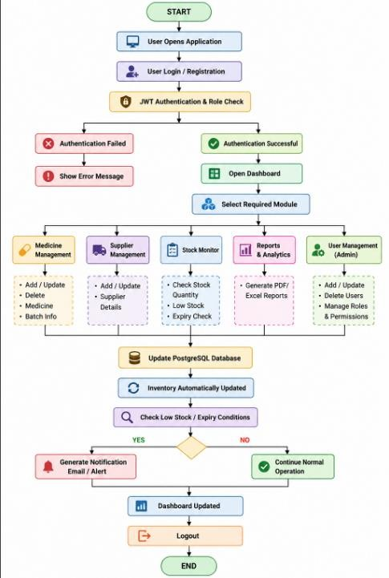

Step 1: User Login
  - The user opens the MediStock application.
  - Logs in using username/password or OAuth2.
  - Spring Security verifies credentials using JWT. Step 2: Authentication
  - If login fails → Error message.

  - If successful → User is redirected to the Dashboard according to their role (Admin, Pharmacist, Staff).
Step 3: Dashboard
The dashboard provides access to different modules:
  - Medicine Management
  - Supplier Management
  - Stock Monitoring
  - Reports & Analytics
  - User Management (Admin) Step 4: Medicine Management Users can:
  - Add medicine
  - Update medicine
  - Delete medicine
  - Manage medicine batches
  - Update stock
Step 5: Supplier Management Users can:
  - Add suppliers
  - Edit supplier details
  - View purchase history
  - Manage procurement Step 6: Stock Monitoring The system automatically:
  - Tracks stock quantity
  - Detects low stock
  - Detects out-of-stock medicines
  - Checks expiry dates
  - Updates inventory after every transaction

Step 7: Database Update
All changes are saved in the PostgreSQL/MySQL database through REST APIs. Step 8: Notification System
If:
  - Stock is below the minimum level, or
  - Medicines are nearing expiry, the system sends:
  - Email notifications
  - Dashboard alerts
  - Purchase reminders Step 9: Reports
Users can generate:
  - Inventory Report
  - Purchase Report
  - Expiry Report
  - Supplier Report
Reports can be exported as:
  - PDF
  - Excel Step 10: Logout
The user logs out securely, ending the session.

User Roles
Admin
Responsibilities:
  - Manage all users

  - Manage medicines
  - Manage suppliers
  - Generate reports
  - View analytics
  - Configure system settings

Pharmacist Responsibilities:
  - Add medicines
  - Update stock
  - Check expiry
  - Generate purchase orders
  - Search medicines

Staff
Responsibilities:
  - View inventory
  - Update stock quantities
  - Search medicines
  - Record stock movement

Functional Requirements
  - Secure user login using JWT and OAuth2 authentication.
  - Role-based access for Admin, Pharmacist, and Staff.
  - Add, update, delete, and manage medicine records.
  - Maintain medicine categories, batch details, and stock quantities.

  - Manage supplier information and purchase records.
  - Monitor medicine stock and generate low-stock alerts.
  - Track medicine expiry dates and notify users of near-expiry or expired stock.
  - Search and filter medicines by name, category, supplier, batch number, and stock status.
  - Display dashboards with inventory statistics and analytics.
  - Generate inventory, purchase, and expiry reports in PDF and Excel formats.
  - Send email and push notifications for important inventory events.
  - Maintain inventory history and stock movement records.

Non-Functional Requirements
  - The system should provide a secure and reliable authentication mechanism.
  - The application should have a simple, user-friendly, and responsive interface.
  - The system should deliver fast response times during normal usage.
  - The application should support multiple users simultaneously.
  - The system should ensure data accuracy and consistency.
  - The application should be scalable to accommodate future enhancements.
  - The codebase should be modular and easy to maintain.
  - The system should be compatible with modern web browsers and devices.
  - Regular database backup and recovery mechanisms should be supported.
  - The system should maintain logs for monitoring and auditing purposes.
  - The application should ensure high availability and reliable performance.

System Architecture Diagram

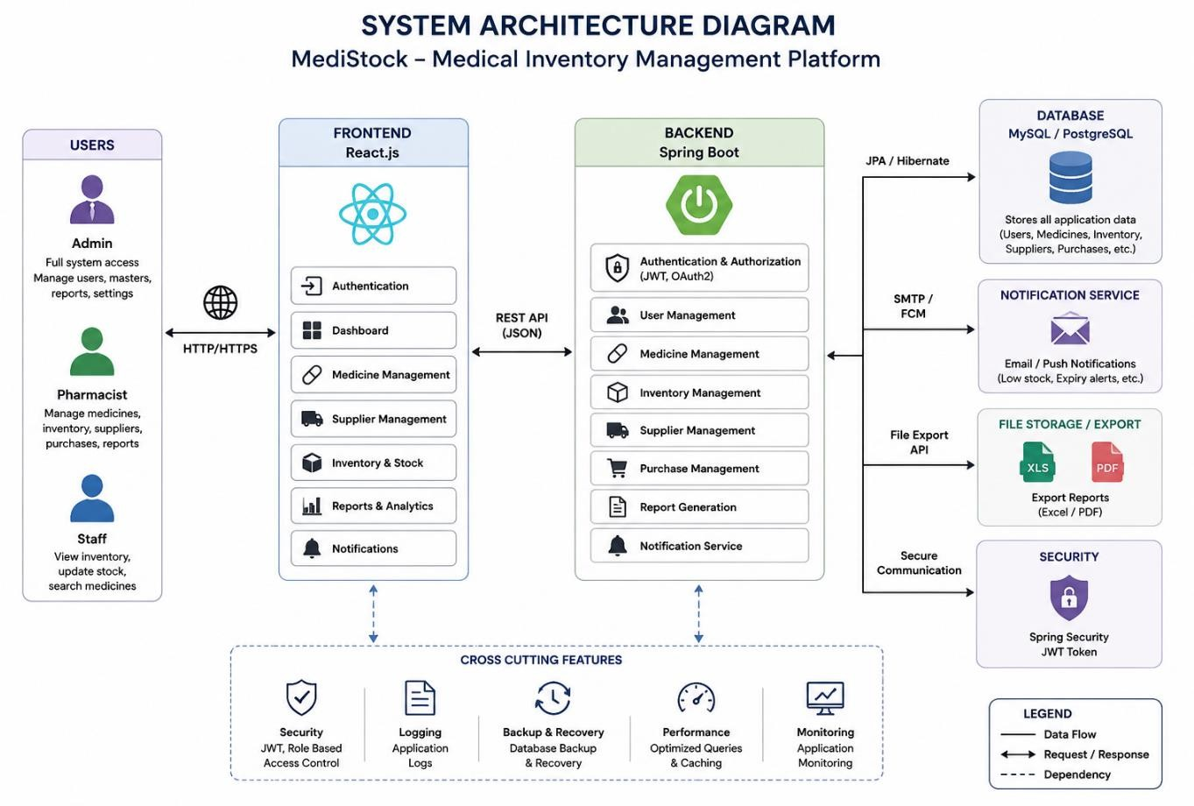

Architecture Explanation

The MediStock application follows a three-tier architecture, which separates the system into presentation, business, and data layers.
- Presentation Layer (Frontend)
  - Developed using React.js
  - Provides the user interface for Admin, Pharmacist, and Staff
  - Handles user interactions and sends requests to the backend through REST APIs

- Application Layer (Backend)
  - Developed using Spring Boot
  - Implements business logic and application workflows
  - Handles authentication, inventory management, supplier management, reporting, and notifications
  - Exposes secure REST APIs for frontend communication

- Data Layer
  - Uses MySQL/PostgreSQL for storing application data
  - Maintains information related to users, medicines, suppliers, inventory, purchase records, and reports

Supporting Services
  - JWT Authentication for secure user login and authorization
  - Notification Service for low-stock and expiry alerts
  - PDF/Excel Export for report generation

